**Manuscript title (not more than 20 words)**

**Instructions:**

1. Insert your information (by replacing) the yellow highlighted text.
2. Do not change the font type or font size.
3. Tables and figures should only be included at the end of this document.

FirstName MiddleName LastNamea, FirstName MiddleName LastNameb, FirstName MiddleName LastNamec, FirstName MiddleName LastNamed, FirstName MiddleName LastNamee

*aDepartment Name, Institution Name, City, State/Province, Country*

*bDepartment Name, Institution Name, City, State/Province, Country*

*cDepartment Name, Institution Name, City, State/Province, Country*

*dDepartment Name, Institution Name, City, State/Province, Country*

*eDepartment Name, Institution Name, City, State/Province, Country*

*Corresponding Author:

FirstName MiddleName LastName

Street Address, City, State/Province, Zip code, Country

Email address: corresponding_author_email@email.com

(A maximum of two corresponding authors is permitted)

Running title: (A maximum of 60 characters long, including spaces)

**Abstract.**

* Provide an abstract of 250 words or less in a single paragraph.
* The content should highlight the background, problem statement, hypothesis, methodology, findings and conclusion of the study.
* Do not include reference(s) here.

**Keywords:** Provide a maximum of 6 keywords in alphabetical order suitable for indexing.

**INTRODUCTION**

* Provide your introduction here.
* All figures and tables should only be included at the end of this document. Do cite your figures and tables in-text (Figure 1, Table 1…) in ascending numerical order.
* For in-text citation, use the author’s last name and the year of publication, for example (Hoffman, 2023), (Hoffman & Chanda, 2023), and (Hoffman *et al.*, 2023).

**MATERIALS AND METHODS**

* Provide your materials and methods/methodology here.
* Provide an ethics statement if the study involves human/animal subjects, including the name of the granting organisation and the approval reference numbers. If an approval reference number is not provided, a written approval must be attached during the manuscript submission.

**RESULTS / RESULTS AND DISCUSSION**

Provide your results (and discussion - if combined) here.

**DISCUSSION (- if separate from results)**

Provide your discussion here (if separated). Otherwise, delete this section.

**CONCLUSION**

Provide your conclusion here.

**ACKNOWLEDGEMENTS**

Provide your acknowledgements here. Otherwise, state the following: None.

**CONFLICT OF INTEREST**

Declare any conflict of interest that exists. Otherwise, state the following: The authors have declared that no conflict of interest exists.

**FUNDING**

Provide your funding details here. Otherwise, state the following: None.

**ETHICS STATEMENT**

If the study involves an experiment on humans and animals; then the name of the authorizing body should be stated. Otherwise, state the following: Not applicable.

**REFERENCES**

Provide your references here. You can submit your manuscript in any reference format for the review process. However, you are required to use the following format after the manuscript is accepted for publication. DOI of a cited article, if present, must be included in its citation. For a long author list, the eleventh and subsequent authors should be abbreviated as “*et al.*”.

Author(s) Name. Year. Article title. *Journal Title* Volume(Issue): Page number. DOI

Example:

**Journal**

Abd-Aziz, N., Stanbridge, E. J., & Shafee, N. 2016. Newcastle disease virus degrades HIF-1α through proteasomal pathways independent of VHL and p53. *Journal of* *General Virology* 97(12): 3174-3182. https://doi.org/10.1099/jgv.0.000623

Desai, N. R., Kohli, P., Giugliano, R. P., O’Donoghue, M. L., Somaratne, R., Zhou, J., Hoffman, E. B., Huang, F., Rogers, W. J., Wasserman, S. M. *et al.* 2013. AMG145, a monoclonal antibody against proprotein convertase subtilisin kexin type 9, significantly reduces lipoprotein(a) in hypercholesterolemic patients receiving statin therapy. *Circulation* 128(9): 962-969. https://doi.org/10.1161/CIRCULATIONAHA.113.001969

**Conference paper**

Basurra, R. S., Salim N., Idorus, M. Y., Wang, S. M., & Alhoot A. 2023. Antiviral activity of thymoquinone against herpes simplex virus. 5th International Conference of Molecular Biology & Biotechnology. Kuala Lumpur, Malaysia.

**Book Chapter**

Chan, T. K. 1992. Plasmids of enterobacteria. In: Pathogenesis of bacterial infections. Ed. Ramirez, A. & Aquino, S. pp. 235-243. Kuala Lumpur: Protea Press.

Wang, S. M. & Raju, C. S. 2024. Traditional and current diagnosis. In: Dengue diagnostics. Ed. Sekaran, S. D. pp. 17-38. Singapore: Jenny Stanford Publishing Pte. Ltd.

**Book**

Herlina, S. & Tan, F.H. 1992. Molecular aspects of typhoid fever. Kuala Lumpur: Protea Press.

**Personal Communications**

These should be mentioned in the text in the following form: (U. Laopinkarn, pers.comm.)

**Tables:**

Provide all tables and their captions here.

Example:

**Table 1.** Table title

|  |  |  |
| --- | --- | --- |
| **Gene** | **A** | **B** |
| **p53** | 123 | 456 |
| **BRCA-1** | 789 | 123 |

Footnotes (If necessary)

**Table 2.** Table title

|  |  |  |  |
| --- | --- | --- | --- |
| **Characteristic** | **Total (n=300)** | **Baseline X** | ***P* Value** |
| **Age, mean (SD)** | 58 (8.3) | 62 (9.1) | 0.236 |
| **Male, n (%)** | 150 (50) | 149 (5) | <0.050 |
| **Female, n (%)** | 150 (50) | 138 (12) | <0.050 |
| **Body mass index** | 30 (5.6) | 29.8 (4.3) | 0.480 |

Tables should be numbered consecutively (Table 1, Table 2, etc). Tables should bear an appropriate caption, contain horizontal rules only, (one above and one below column headings) and all abbreviations clearly explained in the footnote.

**Figures and Photos:**

Provide all illustrations and photographs of high quality and their captions here.

Example:

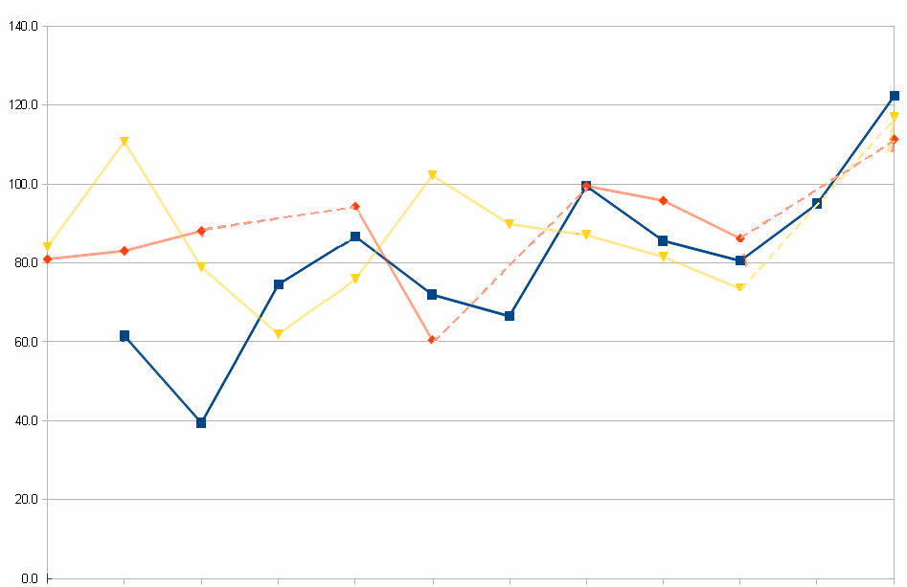

**Figure 1.** Figure caption